**USING RAPTOR – CHECK GIVEN NUMBER PALINDROME OR NOT**

**ANIRUDH.R(192011013)**

**FLOWCHART**

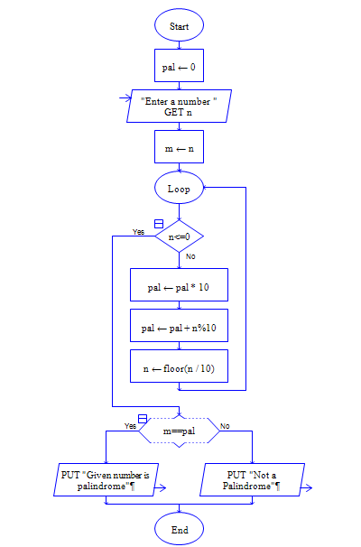

**OUTPUT**

INPUT IS 1234321

